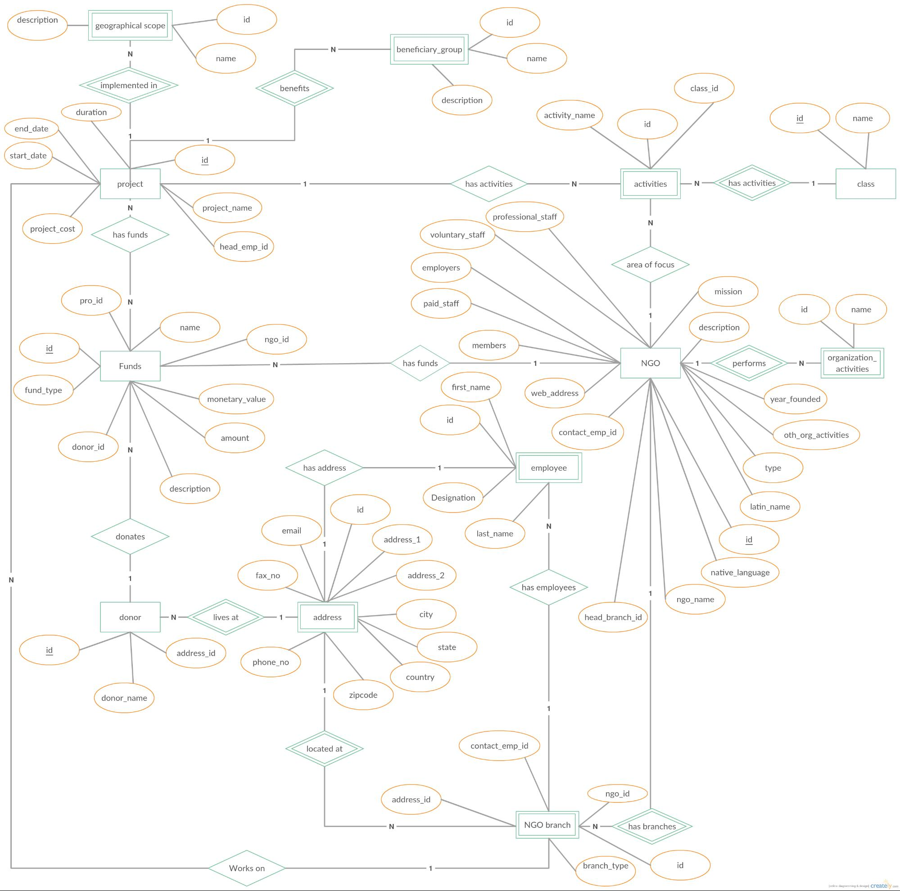

description

geographical scope

beneficiary_group

(

name

name

name

implemented in >>

benefits

>

class_id

description

duration

activity_name

name

end_date

start_date

id

project

has activities

activities

E

N

—

has activities >>

class

project_name

professional_staff

project_cost

has funds

voluntary_staff

head_emp_id

--

employers

area of focus

mission

pro_id

)

Ν

paid_staff

name

name

description

ngo_id

Cid

members

NGO

has funds

Funds

organization_

activities

performs

fund_type

first_name

web_address

monetary_value

year_founded

id

contact_emp_id

oth_org_activities

amount

donor_id

N.

has address

employee

type

description

Designation

latin_name

email

donates

last_name

address_1

fax_no

address_2

native_language

<has employees

ngo_name

donor

EN—

lives at lives at

>>

address

city

head_branch_id

state

address_id

phone_no

country

donor_name

zipcode

located at

»

contact_emp_id

ngo_id

address_id

NGO branch

N—

has branches >

Works on

branch_type

[online diagramming & design] creately.com